**Lab18 – Understanding Read-Access Geo-Redundant Storage (RA-GRS) - Azure**

**Read-access geo-redundant storage**

Read-access geo-redundant storage (RA-GRS) maximizes availability for your storage account. RA-GRS provides read-only access to the data in the secondary location, in addition to geo-replication across two regions.

When you enable read-only access to your data in the secondary region, your data is available on a secondary endpoint as well as on the primary endpoint for your storage account. The secondary endpoint is similar to the primary endpoint, but appends the suffix –secondary to the account name. For example, if your primary endpoint for the Blob service is myaccount.blob.core.windows.net, then your secondary endpoint is myaccount-secondary.blob.core.windows.net. The access keys for your storage account are the same for both the primary and secondary endpoints.

Some considerations to keep in mind when using RA-GRS:

* Your application has to manage which endpoint it is interacting with when using RA-GRS.
* Since asynchronous replication involves a delay, changes that haven't yet been replicated to the secondary region may be lost if data can't be recovered from the primary region.
* You can check the Last Sync Time of your storage account. Last Sync Time is a GMT date/time value. All primary writes before the Last Sync Time have been successfully written to the secondary location, meaning that they are available to be read from the secondary location. Primary writes after the Last Sync Time may or may not be available for reads yet. You can query this value using the [Azure portal](https://portal.azure.com/), [Azure PowerShell](https://docs.microsoft.com/en-us/azure/storage/common/storage-powershell-guide-full), or from one of the Azure Storage client libraries.
* If Microsoft initiates failover to the secondary region, you'll have read and write access to that data after the failover has completed. For more information, see [Disaster recovery guidance](https://docs.microsoft.com/en-us/azure/storage/common/storage-disaster-recovery-guidance).
* For information on how to switch to the secondary region, see [What to do if an Azure Storage outage occurs](https://docs.microsoft.com/en-us/azure/storage/common/storage-disaster-recovery-guidance).
* RA-GRS is intended for high-availability purposes. For scalability guidance, review the [performance checklist](https://docs.microsoft.com/en-us/azure/storage/common/storage-performance-checklist).
* For suggestions on how to design for high availability with RA-GRS, see [Designing Highly Available Applications using RA-GRS storage](https://docs.microsoft.com/en-us/azure/storage/common/storage-designing-ha-apps-with-ragrs).

**Topology:**

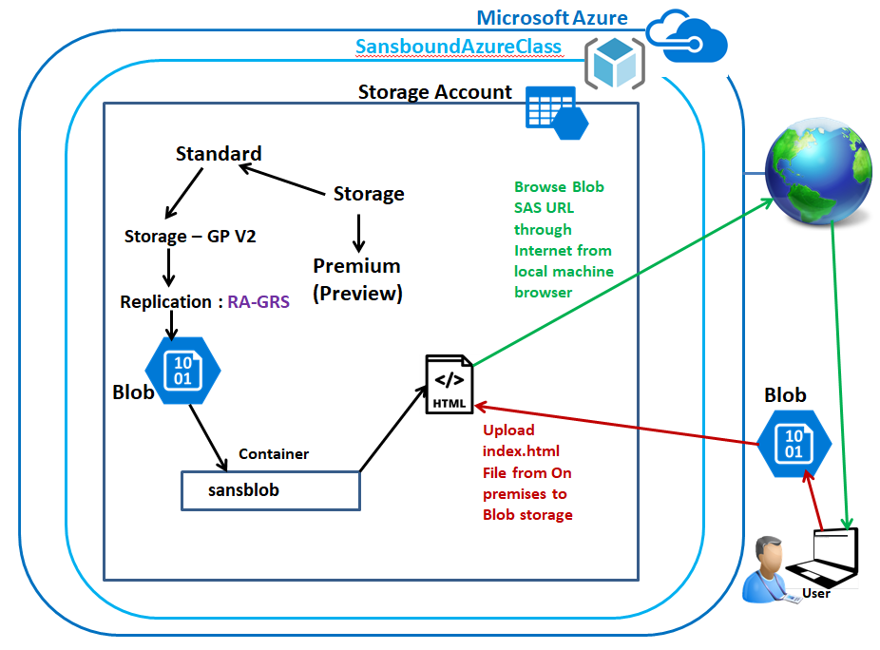

**Back-End Topology:**

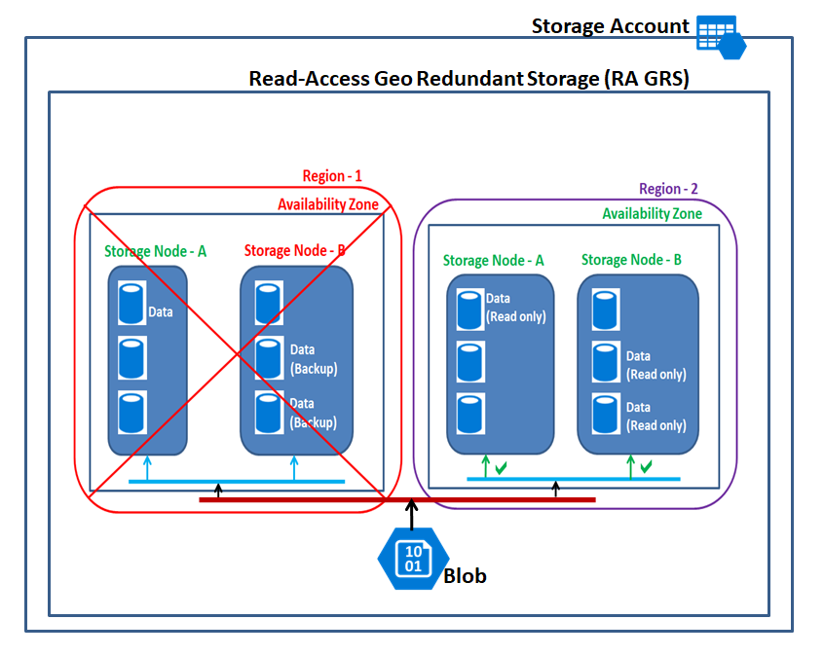

In Azure portal, click **“Resource groups”**.

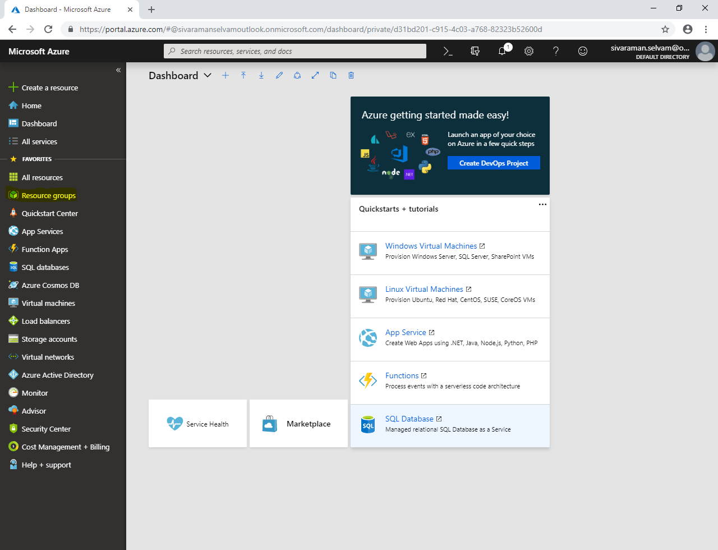

Click **“Add’**.

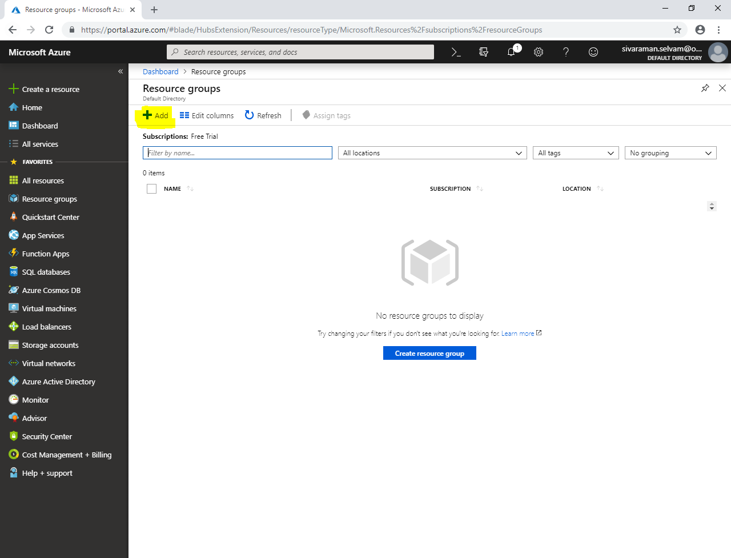

While create **“Resource group”**, type **“Resource group name”** as **“SansboundAzureClass”**.

Select **“Subscription”** as **“Free Trial”**.

Select **“Resource Group location”** as **“Central US”**.

Click **“Create”**.

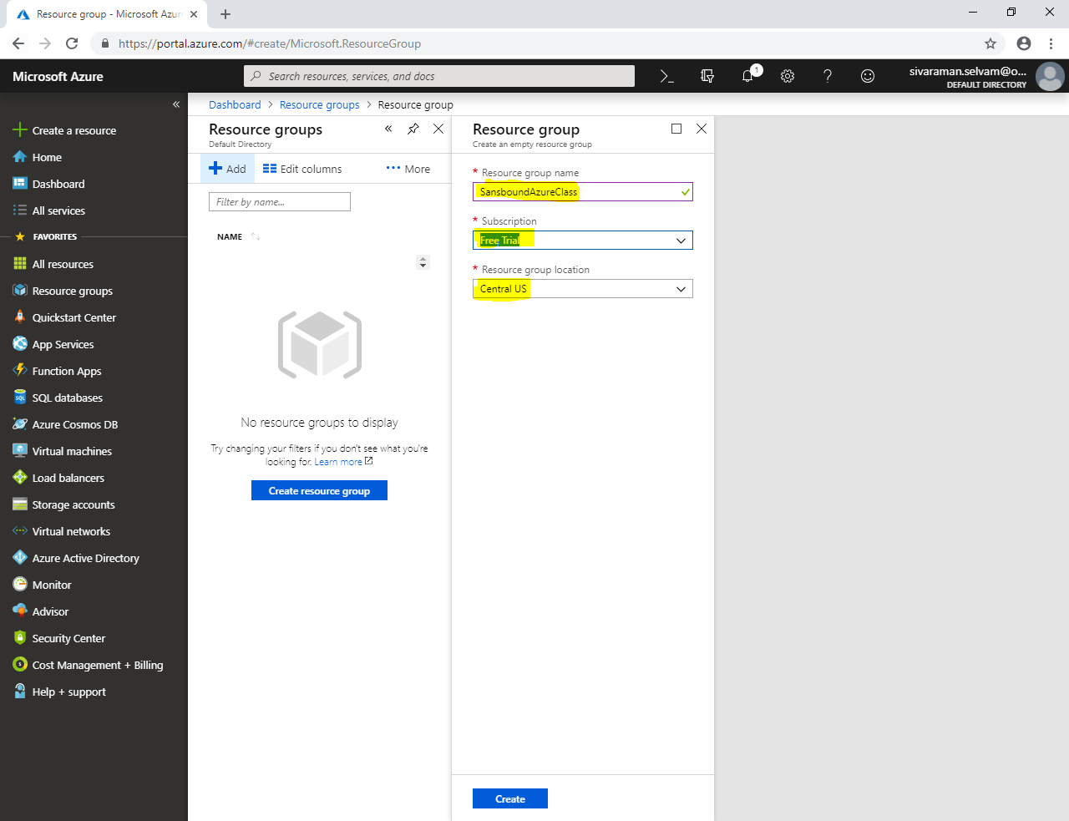

In Portal, Click **“Storage accounts”** in left side panel.

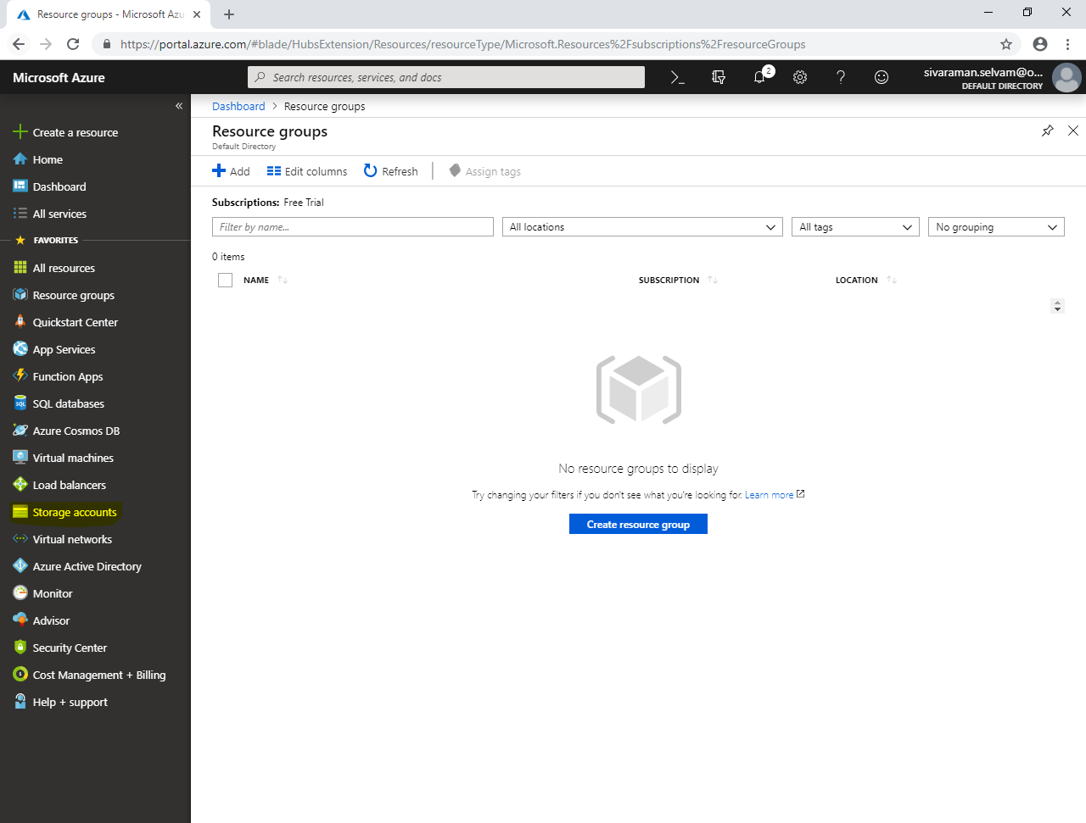

In **“Storage accounts”.**

Click **“Add”**.

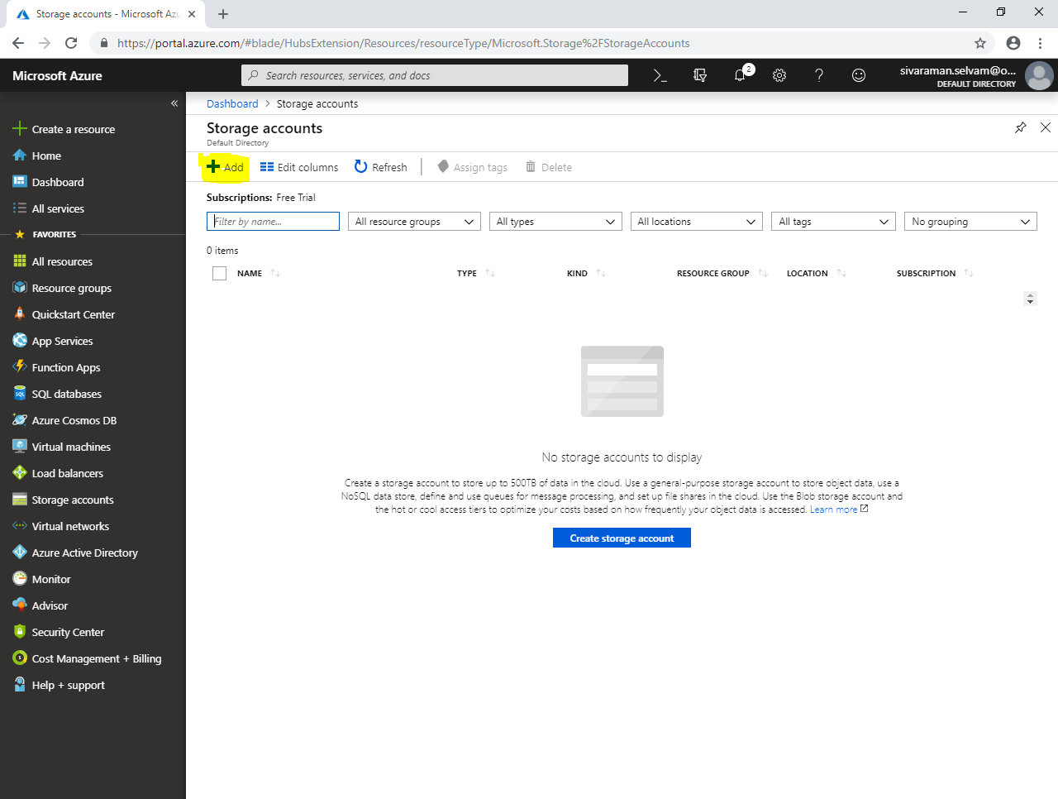

Select **“Subscription”** as **“Free Trial”**.

Select **“Resource group”** as **“SansboundAzureClass”**.

Type **“Storage account name”** as **“sanboundstorage”**.

Select **“Location”** as **“Central India”**.

Select **“Performance”** as **“Standard”**.

Select **“Account kind”** as **“Storage V2”**.

Select **“Replication”** as **“Read-access geo-redundant storage (RA-GRS)”**.

Click “Access tier” as **“Hot”**.

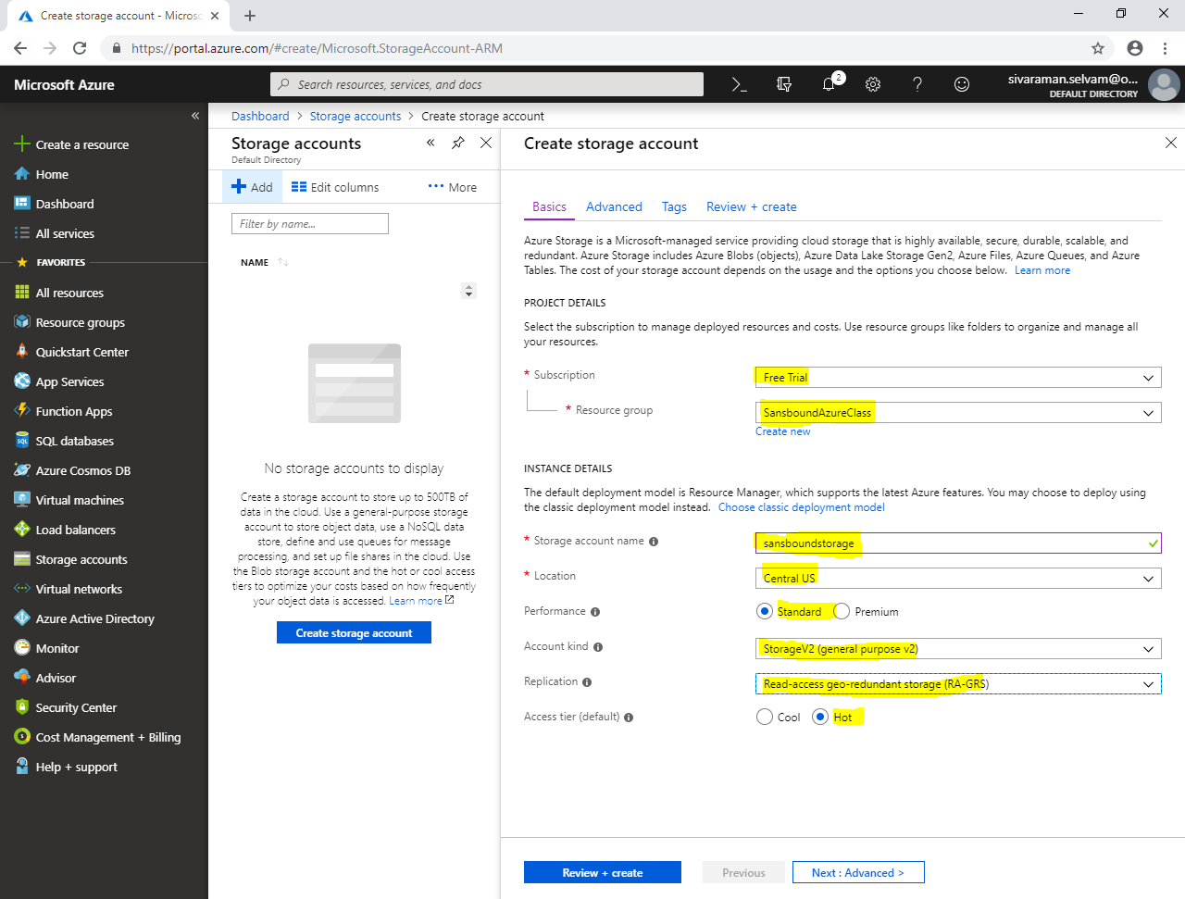

Click **“Next : Advanced”**.

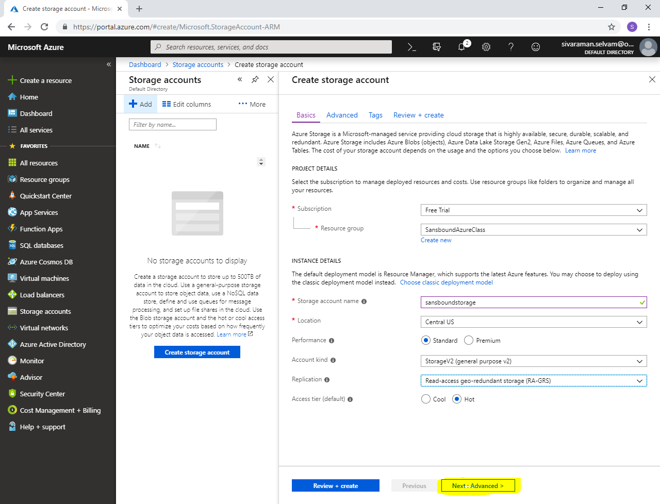

In **“Advanced”, click “Next : Tags >”**.

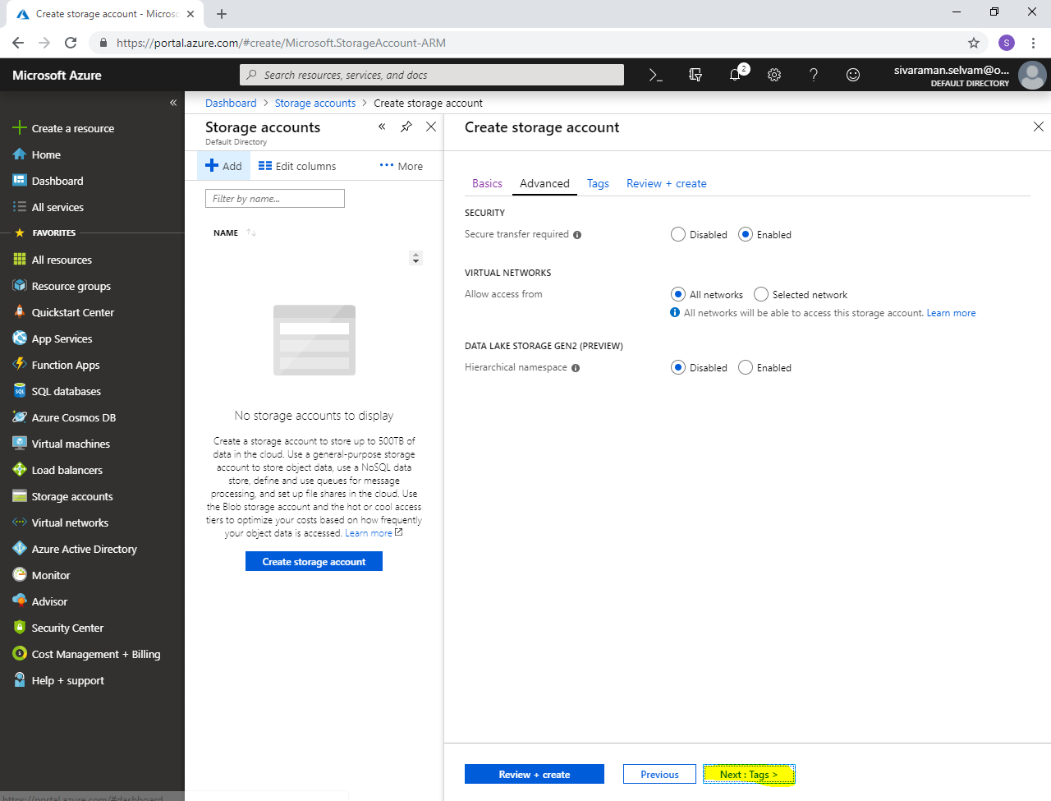

In **“Tags”,**

Type **“Key”** as **“Name”** and **“VALUE”** as **“SansboundStorage”**.

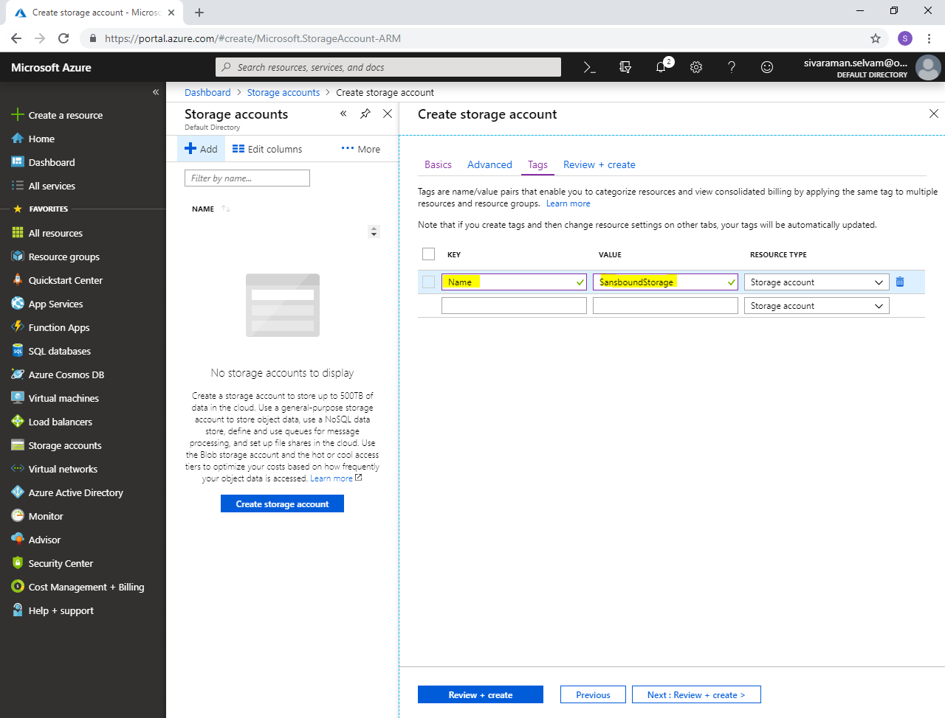

Click **“Next : Review + create”**.

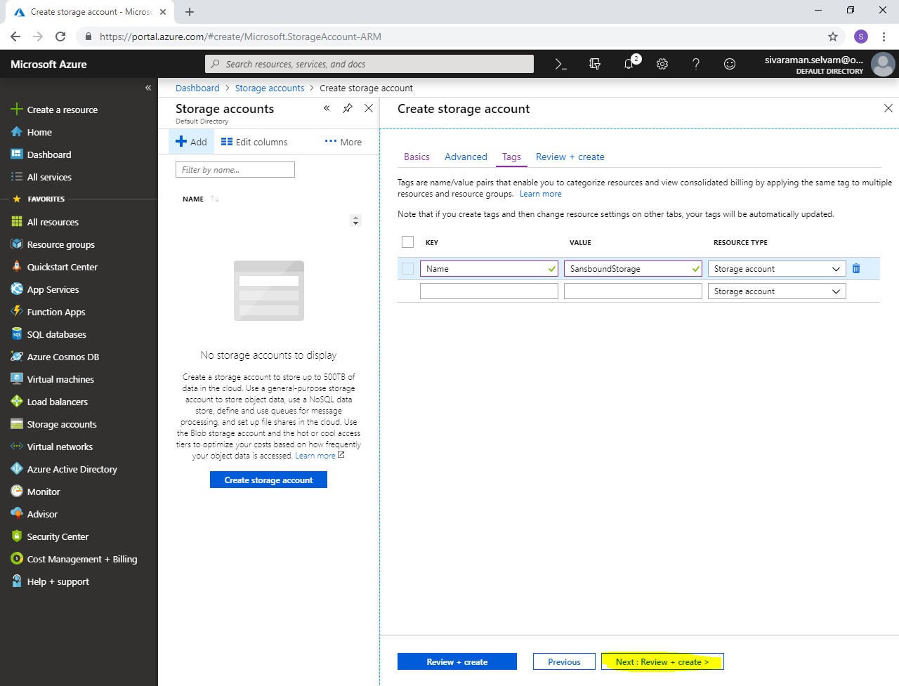

Click **“Create”.**

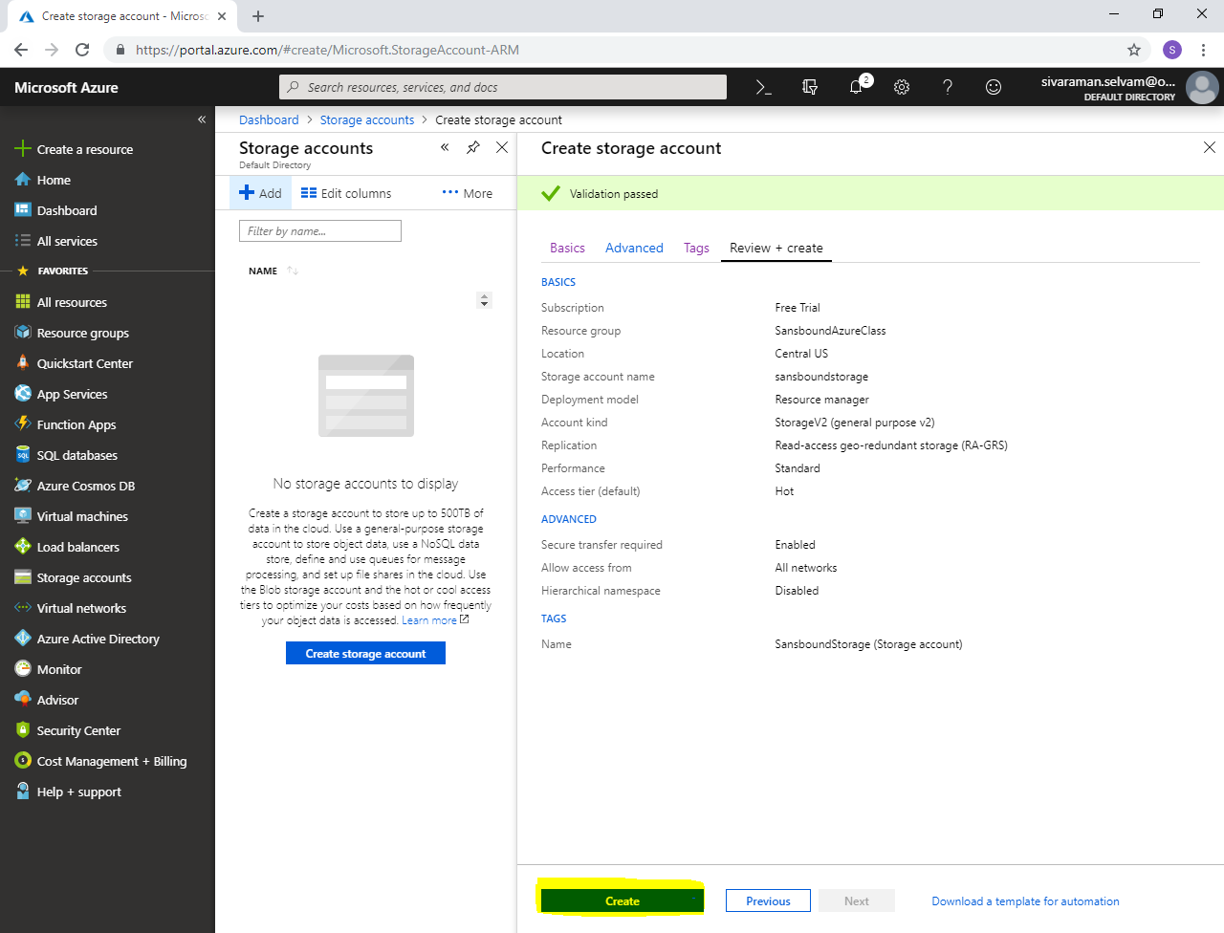

Click **“Go to resource”**.

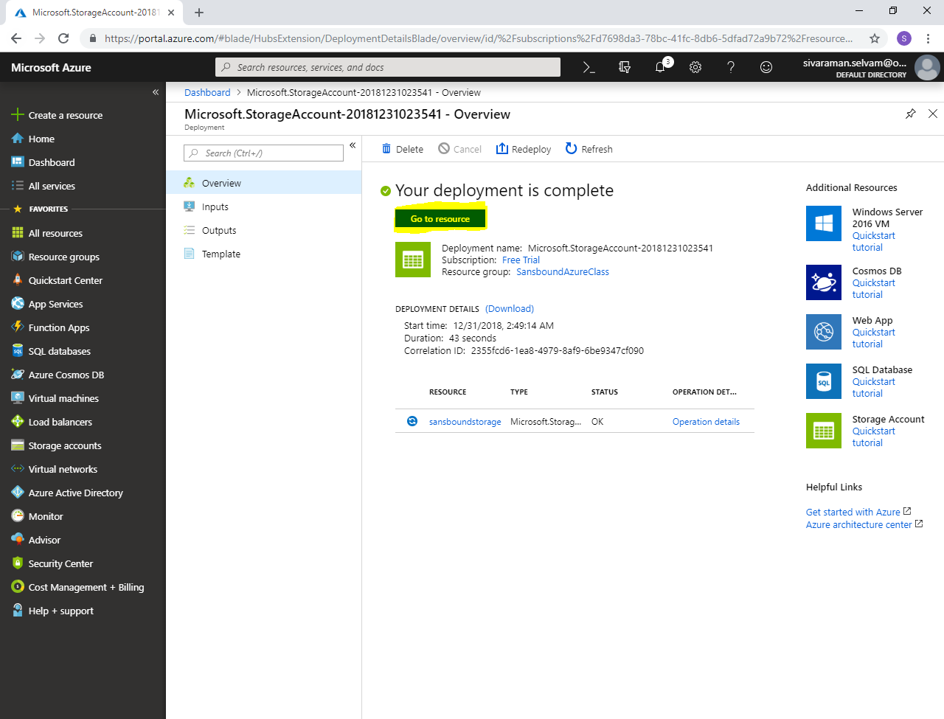

Click **“Blob”.**

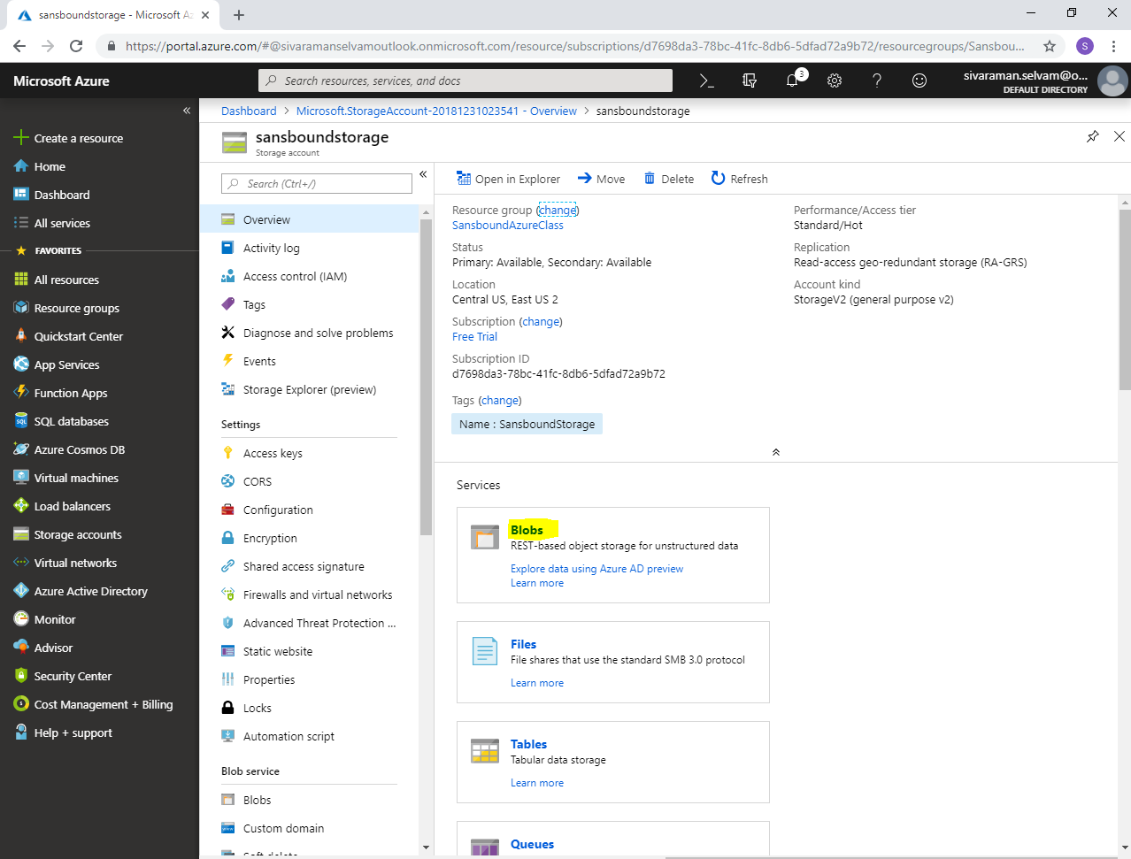

Click **“Container”**.

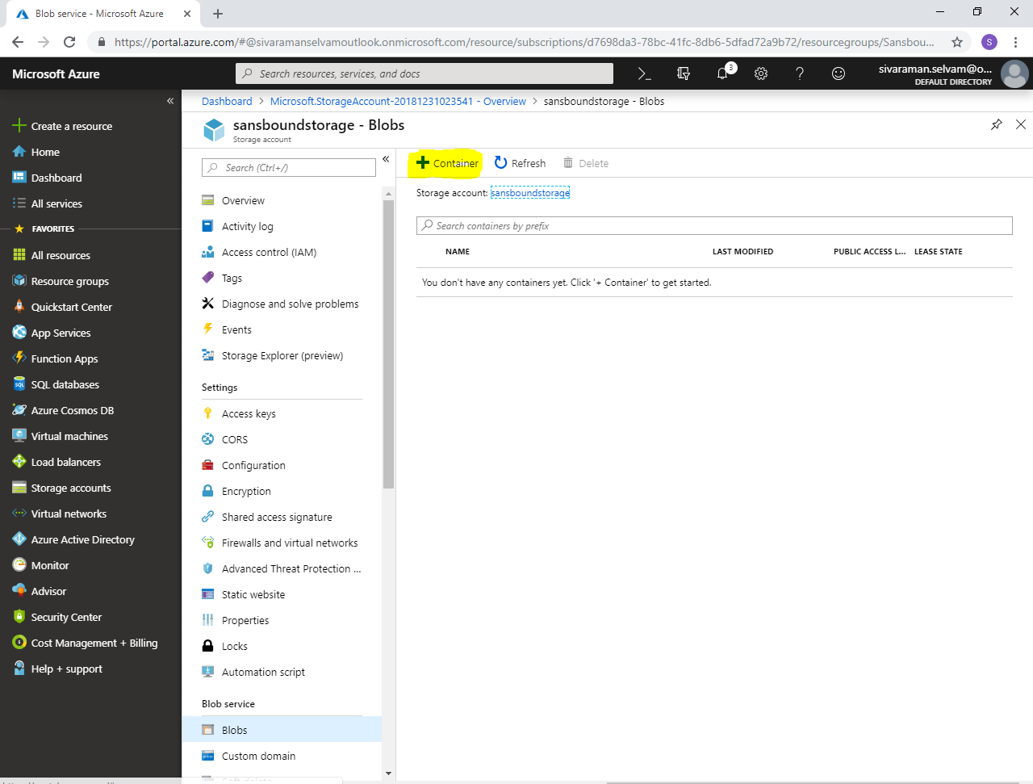

When create new container,

Type **“Name”** as **“sansblob”**.

Select **“Public access level”** as **“Blob”**.

Click **“Ok”**.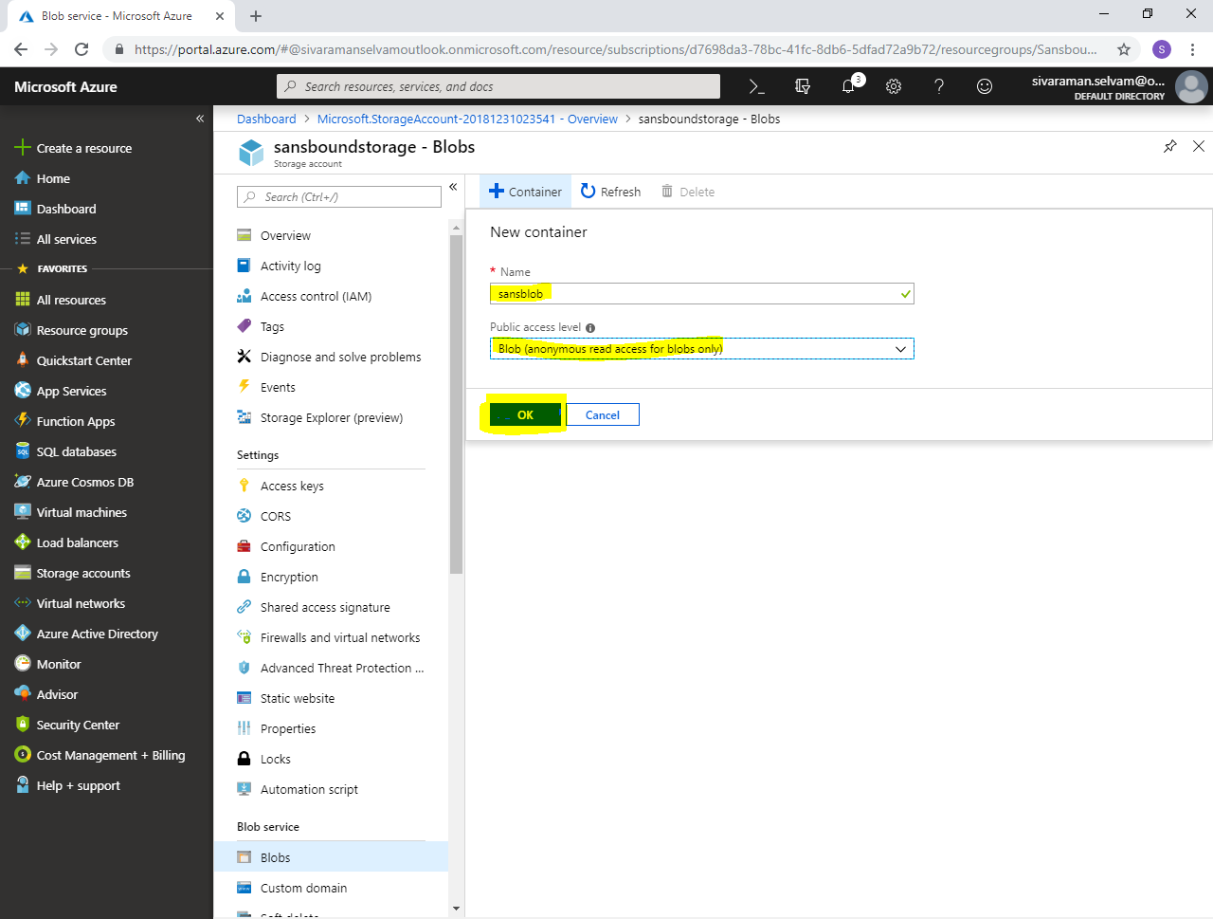

Click **“sansblob”**.

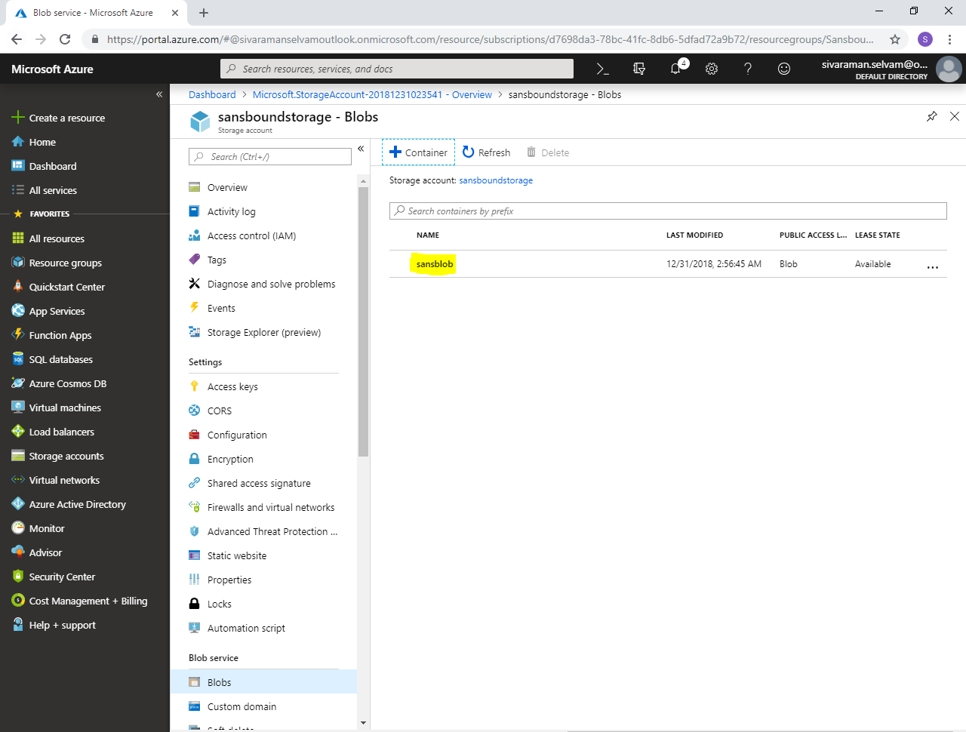

Click **“Upload”**.

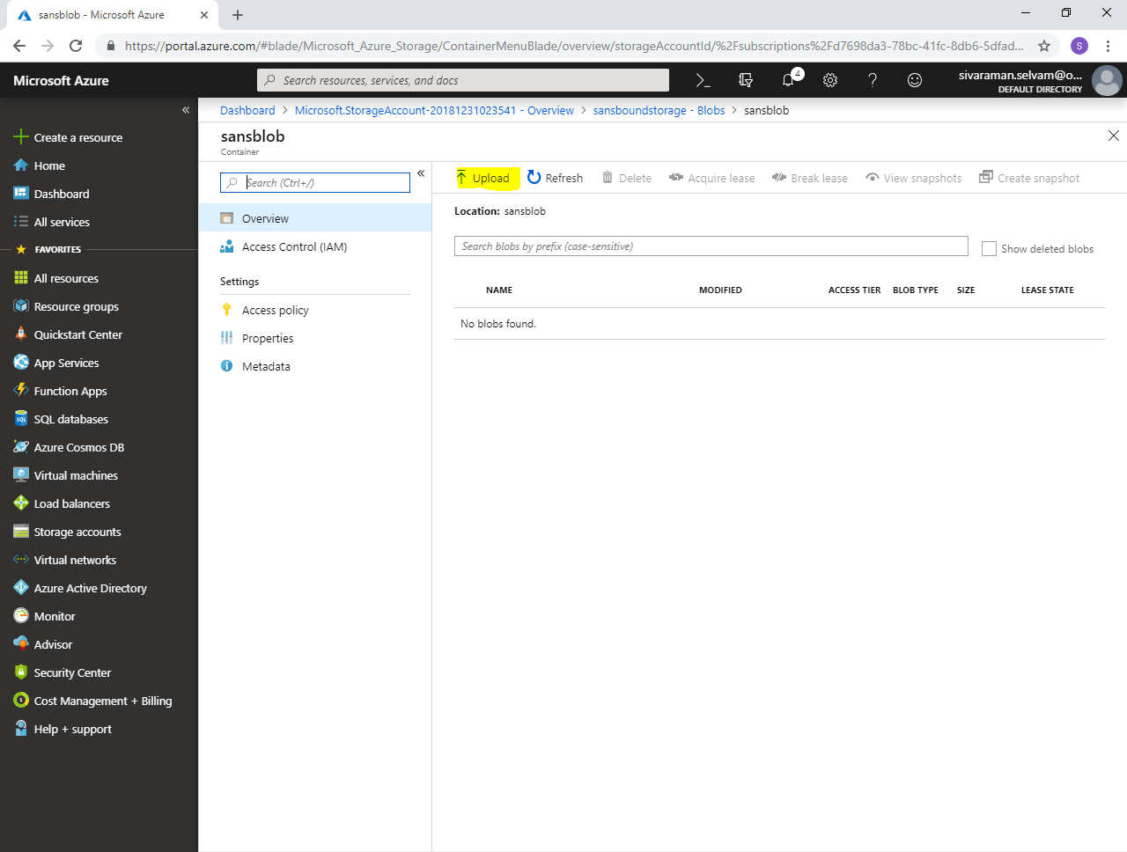

Click **“Icon”**.

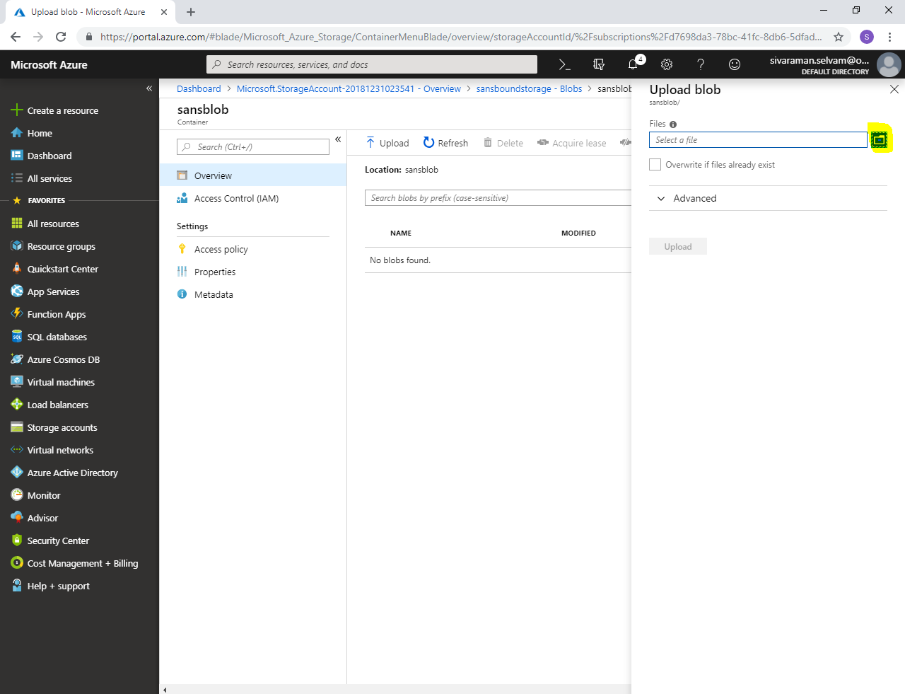

Locate the path of **“Index html”** file which you have required to upload.

Click **“Open”**.

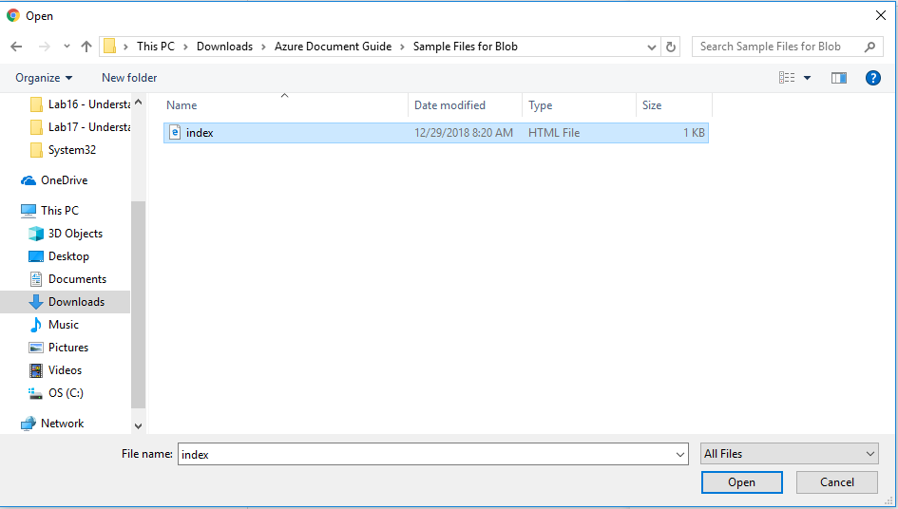

Click **“Upload”**.

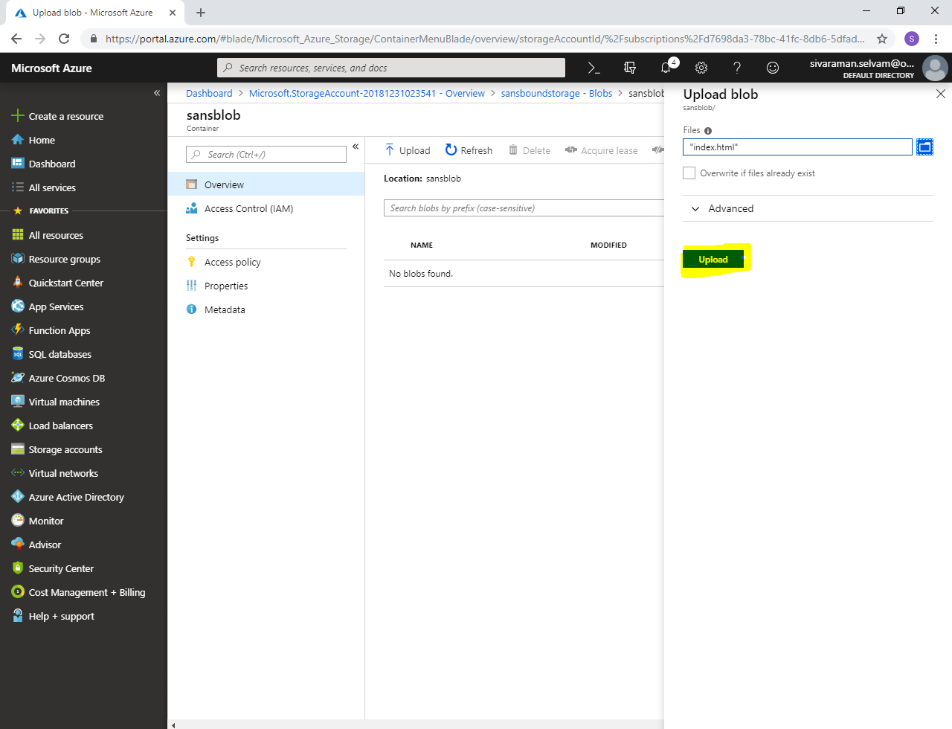

Click **“index.html”**.

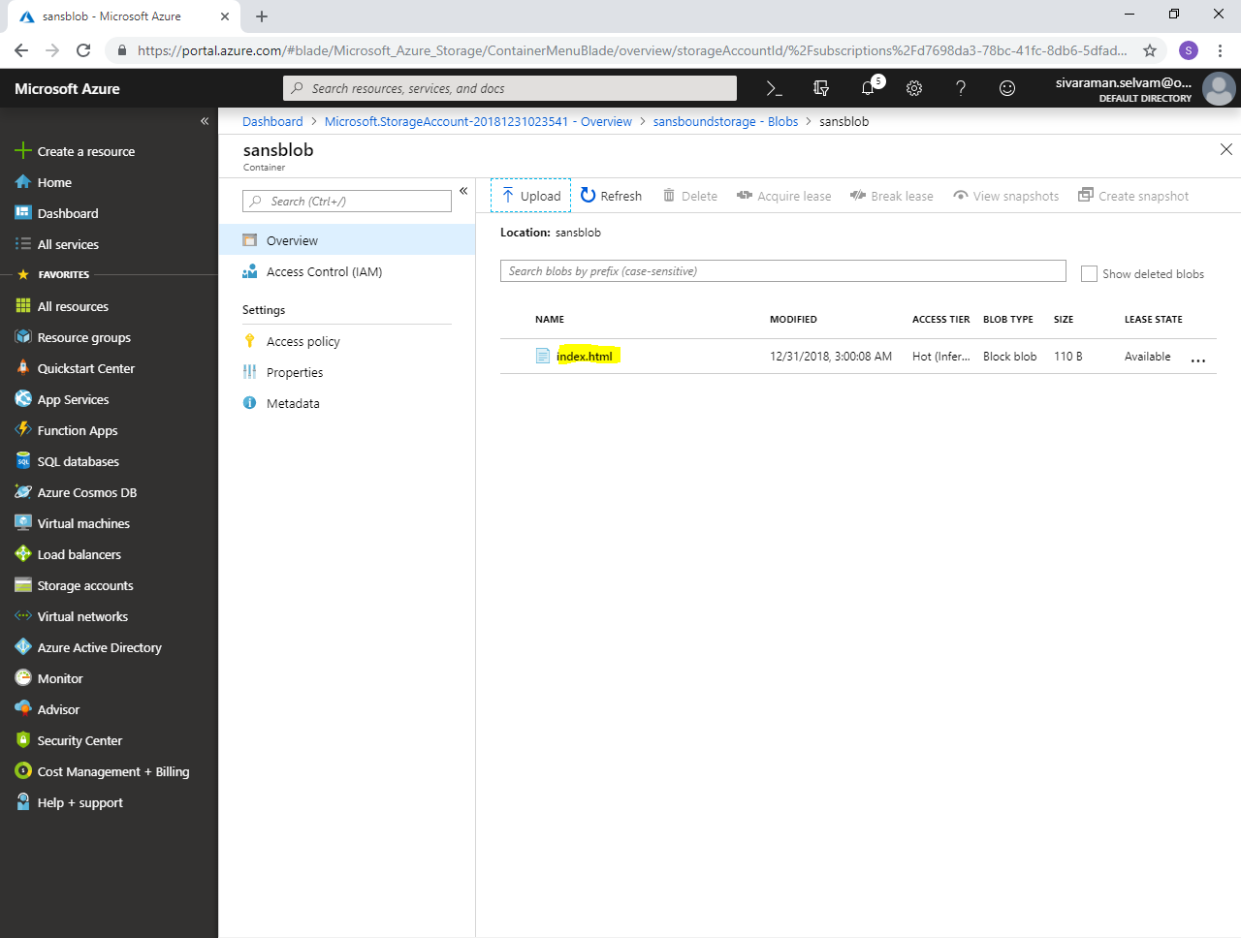

Click **“Generate SAS”**.

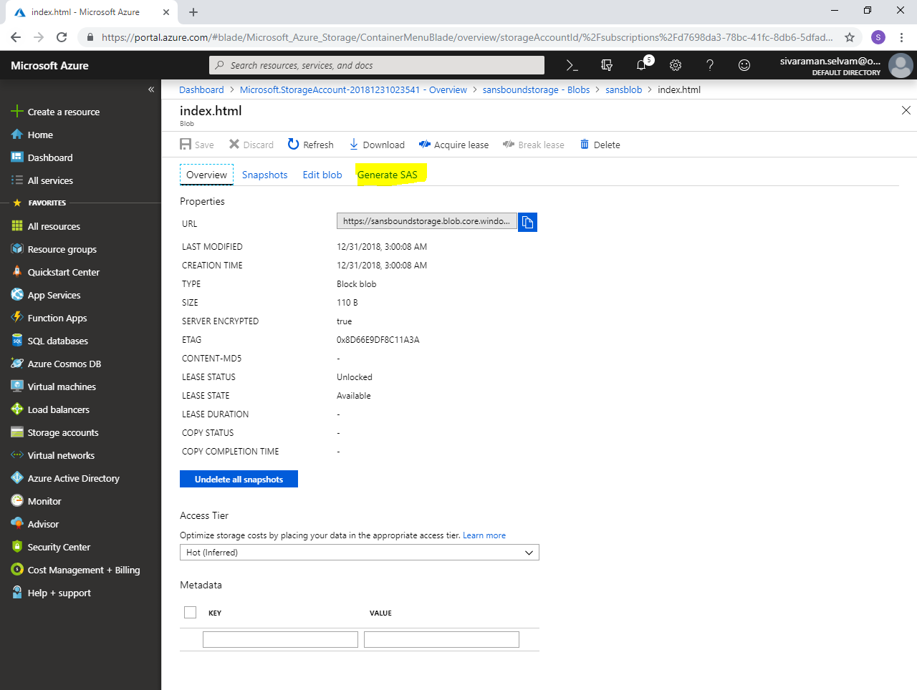

Click **“Generate blob SAS token and URL”**.

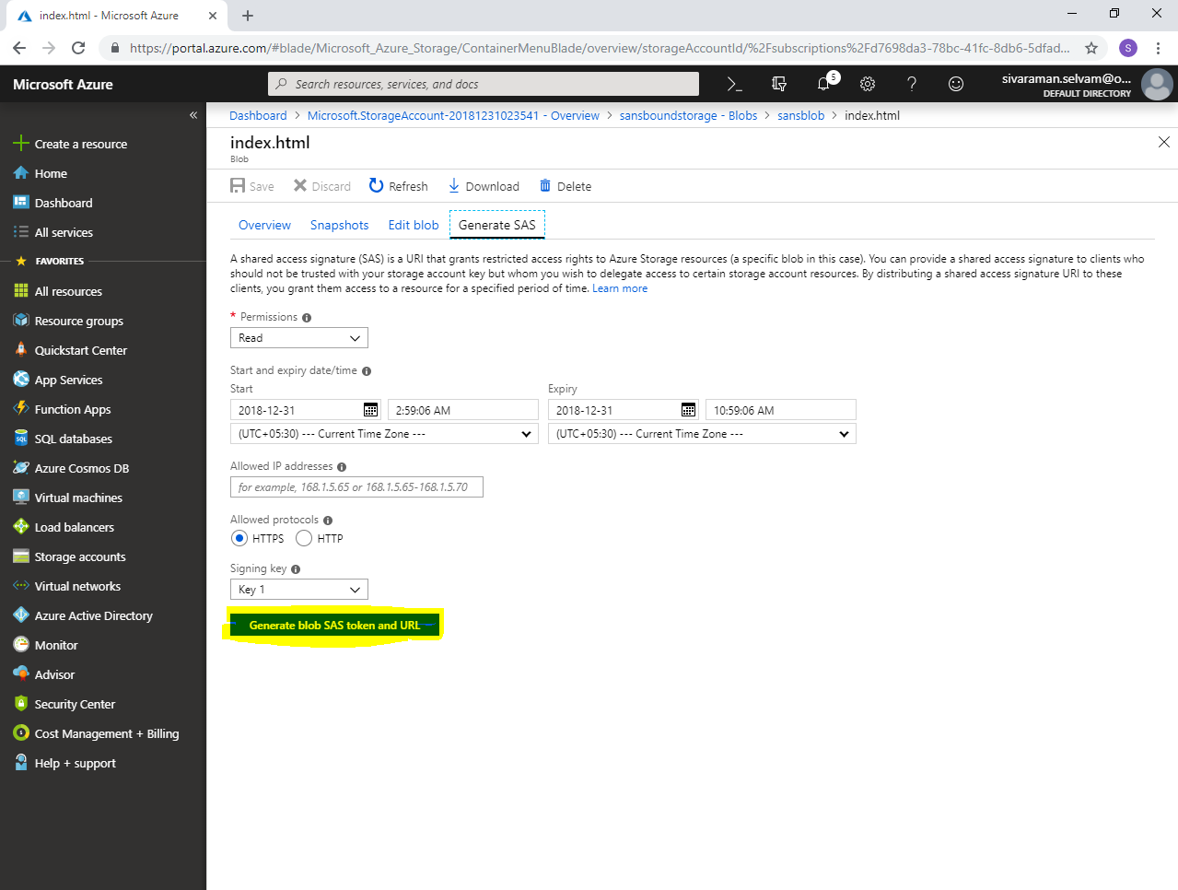

Click **“Icon”** to copy the Blob SAS URL.

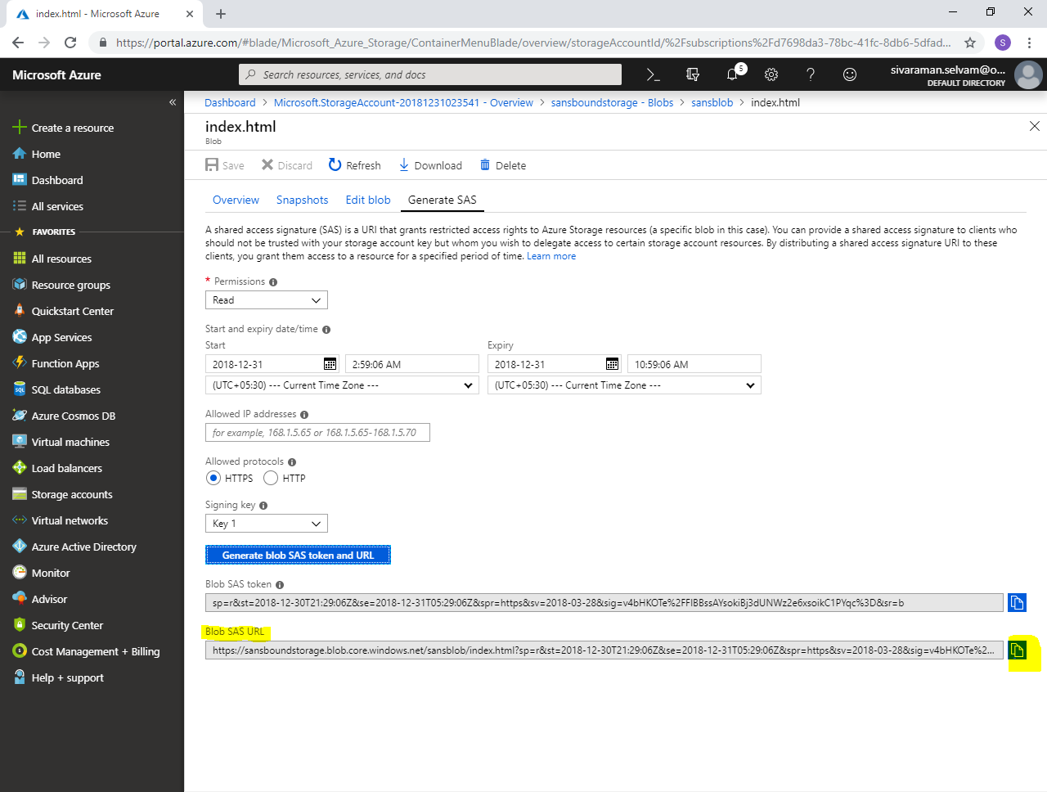

Paste the Blob SAS URL in browser and press **“Enter”**.

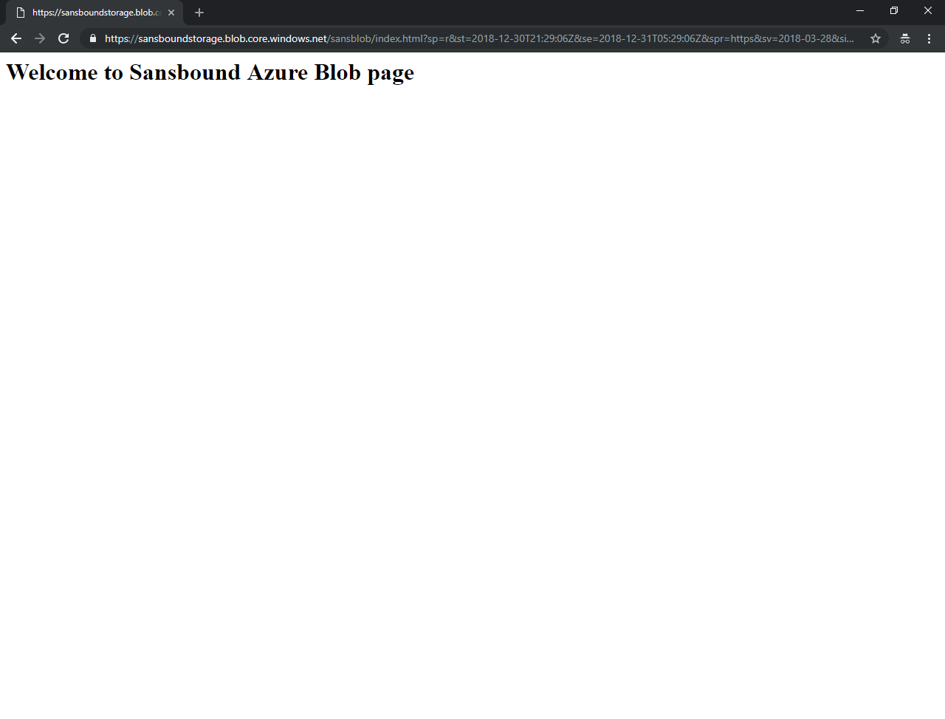

**Note: You have got the page successfully. In case of Region -1 goes down then read only copy of the data will be available in Region -2.**